**DISSERTATION ABSTRACT:**

As we know an attractive resume can catch the eye of the hirer and the chances of hiring can increase heavily. Our app helps you to build custom made resumes using the templates that are present in the app, it also connects you to the hirer looking for the specific employee with a particular skillset. The user can also apply for jobs by searching into the search bar and this serves as the connection between the employee and the employer. If you are registered as an user, you can create posts like those on linkedIN and if you are registered as a manager/hirer, you can create job postings on our app. This app is basically LinkedIN with an additional feature to create an amazing Resume on the go.

**1.1 Purpose of this Document:**

This is a document that lays out the description of the software that is to be developed as well as the intention of the software under development. It will showcase what the software is supposed to do as well as how it is supposed to perform. It serves as a roadmap for the developers and serves as a reference for the clients.

**1.2 Scope of this Document:**

Software requirements specification(SRS) is important for developers because it minimizes the amount of time and effort developers have to expend to achieve desired software goals. It thus reduces development cost. This also benefits the client company because the lesser the development cost, the lesser the developers will charge from the client. And, if composed properly, an SRS ensures that there is less possibility of future redesigns as there is less chance of mistake on the part of developers as they have a clear idea on the functionalities and externalities of the software. It also helps clear any communication problems between the client and the developer.

**1.3 Overview:**

Making and sending out a Resume can be very frustrating and sometimes can be a very tedious job. Our Website aims to simplify this process and make an attractive resume for you in just a few clicks.

Using our resume builder will save you valuable time and money when searching for a job. Why?

Because you do not have to invest the time in researching what main sections you should include in your resume, how to structure the content, finding suitable fonts and colors, what are the trends in the recruitment industry, etc.

All these activities that you need to do actually before starting to write anything take all the fun and excitement out of creating your resume.

Using our resume builder take all those minor details away, and you will have time to focus on the essential part of your resume: the content.

It will also connect you to companies looking to hire, providing you more exposure and increasing your chances of getting hired.

**1.4 Business Context:**

.Our software uses in-built algorithms to find the best resume out of the existing lot and suggest to the hiring company. It also provides suggestions/ autocomplete feature for the users to fill in their details. These features make the website unique and help it stand out of the already existing websites.

**2. General Description:**

**2.1 Product Functions**

Track Account Level Data: In this module, receivables from customers are maintained. User Contact Information: It maintains all the details (Personal, Official, Contact, and Company) of the customer. Maintaining Logs: Activities of the System Users can be tracked through the logs, which is maintained by the system

**2.2 User Characteristics**

Every user should be comfortable working with computers and net browsing. He must have basic knowledge of English too

**2.3 User Problem Statement**

To help users to create their resume quickly and also suggest employees to the companies based on their resume.

**2.4 User Objectives**

To create the best resume possible using the trending templates to

stand out from the crowd and get the job.

**2.5 General Constraints**

1. GUI is only in English.

2. Login and password is used for identification of customers and there is no facility for guests.

3. This system is working for a single server.

4. There is no maintainability of back up so availability will get affected.

5. Limited to HTTP/HTTPS

# **3. Functional Requirements**

1. The website shall support resume building with multiple templates .
2. The website shall support resume hosting , which could be used by recruiters.
3. The website shall contain 2 modes of interfaces - job applicant and recruiter.
4. The website shall contain expert guiding options to help them build a resume.

# **4. Interface Requirements and User Interfaces**

1) Name of use case: **Sign in.**

Description: Accessing the user account Preconditions: There should be an existing account of the user.

Normal flow of events: user details are entered corresponding output if the entries made by the user are correct

2) Name of use case: **Sign up.**

Description: Creating a user account

Preconditions: Knowledge about the website? Existing database ready to accept the details of the user?

Normal flow of events: user details are entered storage of information to the database

3) Name of use case: **Create account.**

Description**:** Creating a user account Preconditions: Knowledge about the website? Existing database ready to accept the details of the user?

Normal flow of events: user details are entered storage of information to the database.

4) Name of use case: **Profile.**

Description: Showing user information Preconditions: Accumulating each and every detail of the user? Retrieving user details from the database?

Normal flow of events: The information regarding the respective user is retrieved from the database Showcasing the entire user information.

5) Name of use case: **Edit profile.**

Description: Making changes to the current profile Preconditions: There should be an existing profile? Normal flow of events: Changes to the existing profile Displaying the changed profile.

6) Name of use case: **Update profile.**

Description: Additions to the existing profile Preconditions: There should be an existing profile? Normal flow of events: Add on to the existing profile Displaying the changed profile.

7) Name of use case: **Change password**.

Description: Creating a new password Preconditions: There should be an existing password? Normal flow of events: Entering the existing password and Entering the new password

8) Name of use case: **Forgot Password.**

Description: Request new password Preconditions: There should be an existing account of the user. Normal flow of events: Enter Email Id / User Name Verify Details Enter new password.

9) Name of use case: **Delete account.**

Description: Deleting the existing account Preconditions: There should be an existing account? Normal flow of events: Accessing the details from the database. Removal of all the details from the database.

10) Name of use case: **Create resume**.

Description: Addition of all the details Preconditions: Accumulating each and every detail of the user at one place Normal flow of events: User sign in Creation of resume as per the user’s choice.

11) Name of use case: **Download resume.**

Description: Download Word file of the resume. Preconditions: User should be logged in? There should be an existing resume Normal flow of events: User vvlogging in Opening the existing resume Downloading the resume.

12) Name of use case: **About Us.**

Description: Gives all company details and required information for the employee’s convenience.

# **5. Performance Requirements**

Very secure - Use HTTPS/SSL for transmission during the login process.

Easy to use and customizable interface.

Users must be able to configure the positioning of various elements.(Which is 1st, 2nd and so on) .

Easy to add various elements such as new publications, or research grants.

Ability to have resume in Microsoft Word, PDF & plain text format. Email functionality for all the above formats.

# **6. Other non-functional attributes:**

1. The website will support Free Resume hosting.
2. The website would have wide range of resume formats
3. Expert guidance at every step of resume building
4. Search for a particular candidate by skills

# **7. Operational Scenarios:**

# The user is prompted with two options,

# 1. Create a resume from scratch

# 2. Upload an existing resume.

# If the user chooses 1, he will be asked to provide details manually and then choose a template and format of the resume. If he chooses the latter, Our software will scan and sort the data in the uploaded document into their respective categories.

# 

# **8. Preliminary Use Case Models and Sequence Diagrams**

**8.1 Use Case Model**

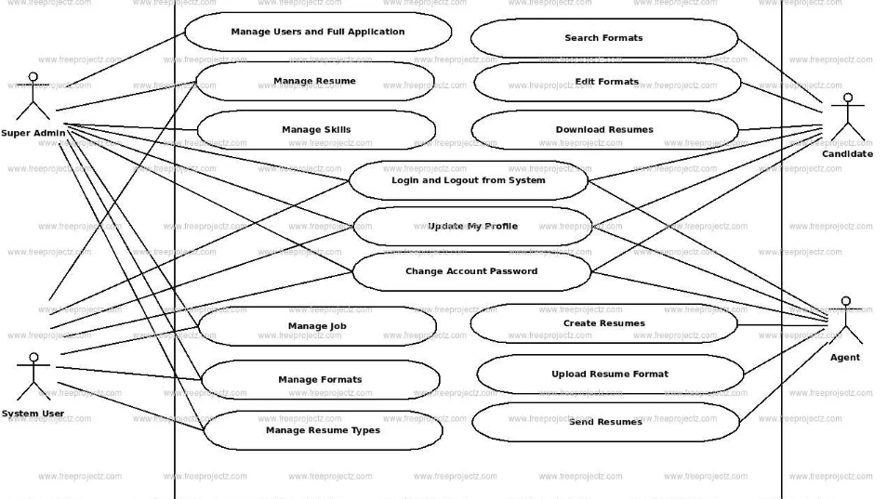

# **8.2 Sequence Diagram**

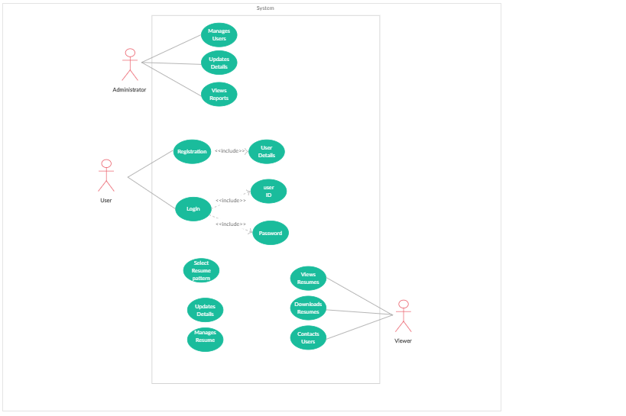

# **9. Updated Schedule**

The project into two phases.

Phase 1: Using Django to create the skeleton of the app.

Phase 2: Integrating Django with React Js.

UPDATE :

Implemented in Django.

* Landing Page
* Storing of Data in the Database

Code snippets below:

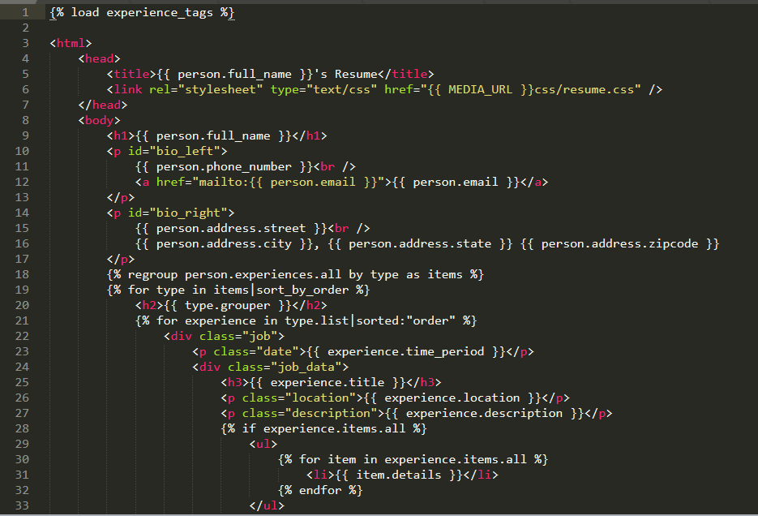

Html page using jinja2 for the page to enter and save all the details that go into your resume.

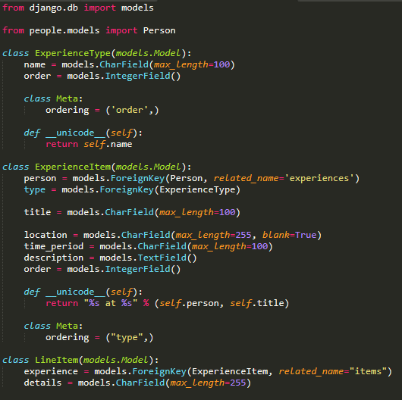

Python code for saving the data entered in the page into the database .

(models.py for the work-experience portion of the resume)

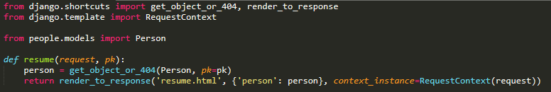

Views.py file

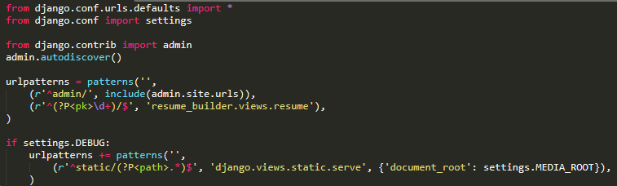

Urls.py

The data is being stored as different sections so that it can further be manipulated for sorting the resume based on the skills or work experience that the users enter.

The css files and the images are saved as static files. Further plan is to create a Hirer section where the Resumes will be listed for the companies to choose from.

Phase 2 update:

Updated Features:

* Only managers can create job invitations describing the requirements , tags of the job.
* Normal users who are following them will get this invite and they can apply for this job.
* React for rendering posts on the homepage
* Managers who have created the invite can view who applied for that job

Only Managers can create job invites , but normal posts can be created by every user

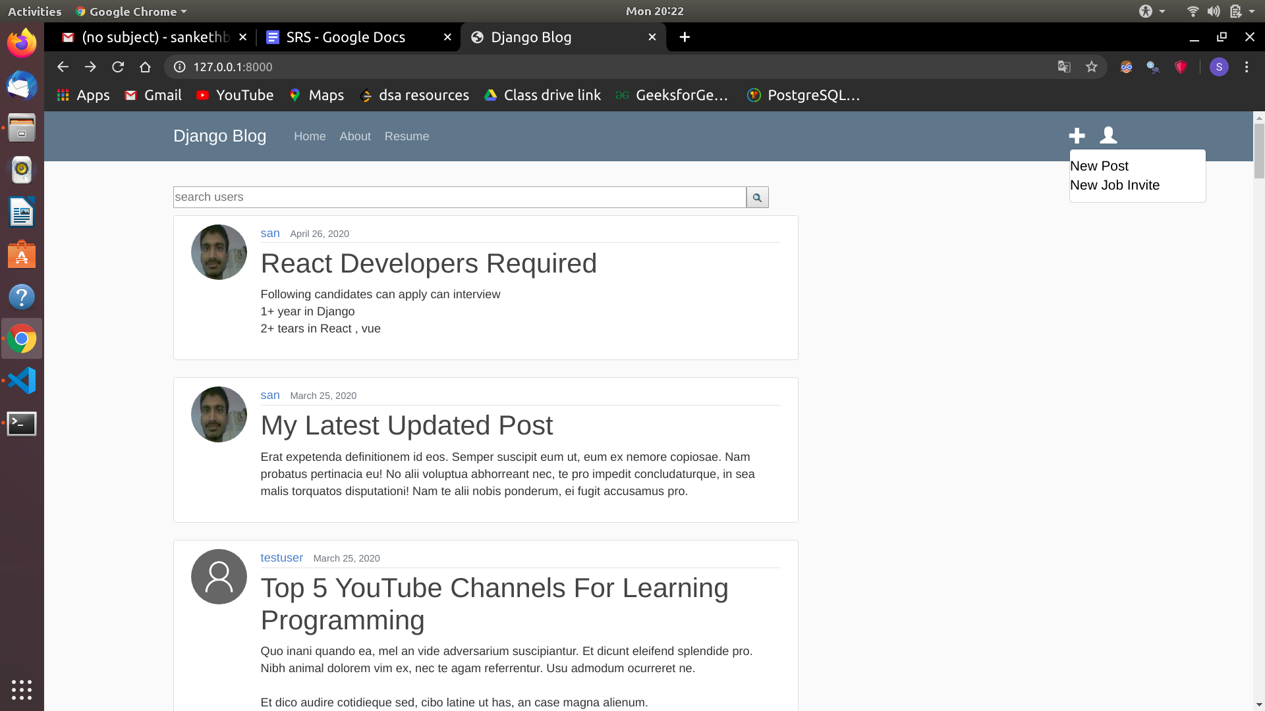

Once a manager posts the post he will get a button view applicants to see the people who have applied for this job

Updated Features:

* Only managers can create job invitations describing the requirements , tags of the job.
* Normal users who are following them will get this invite and they can apply for this job.
* React for rendering posts on the homepage
* Managers who have created the invite can view who applied for that job

Only Managers can create job invites , but normal posts can be created by every user

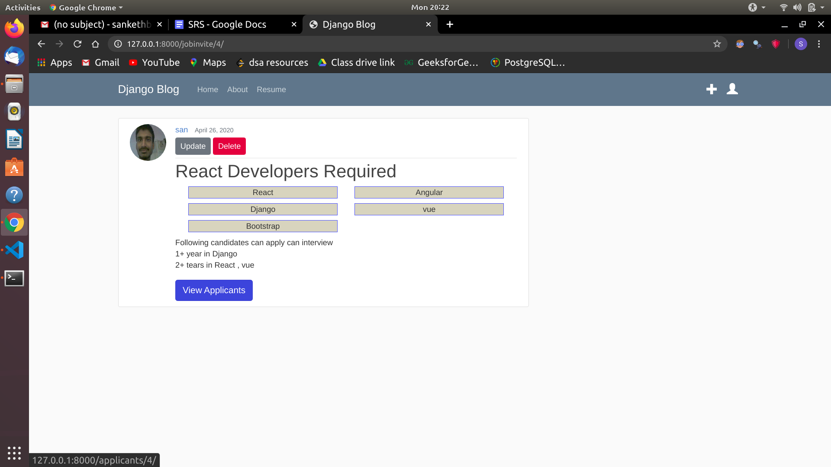

A normal user will get an option to apply for the job

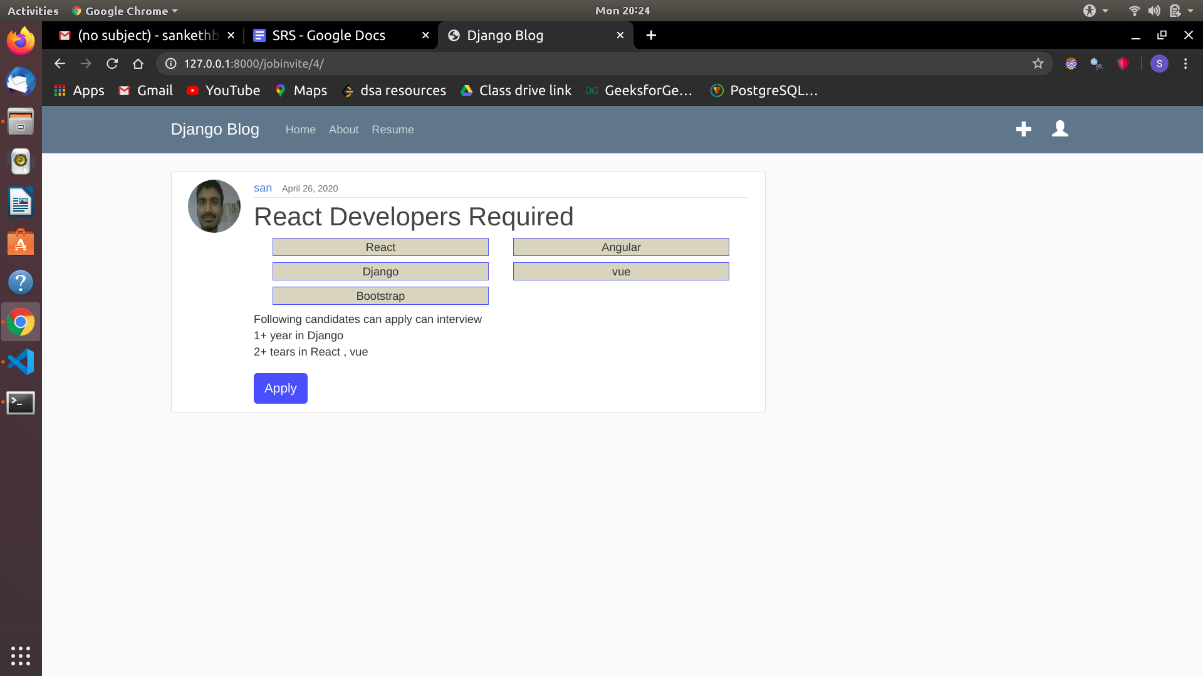

Once he applies for the job it will show as “you have applied for this job”

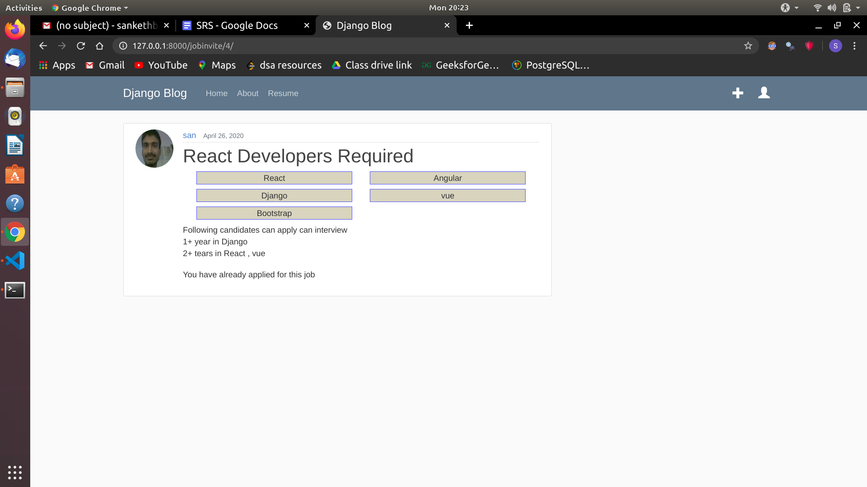

React code used to render posts on homepage

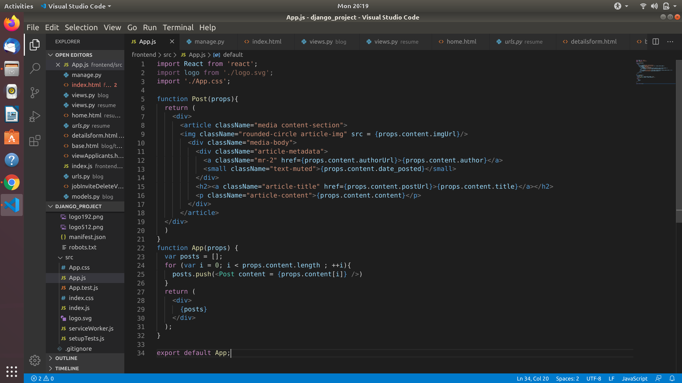

REST API

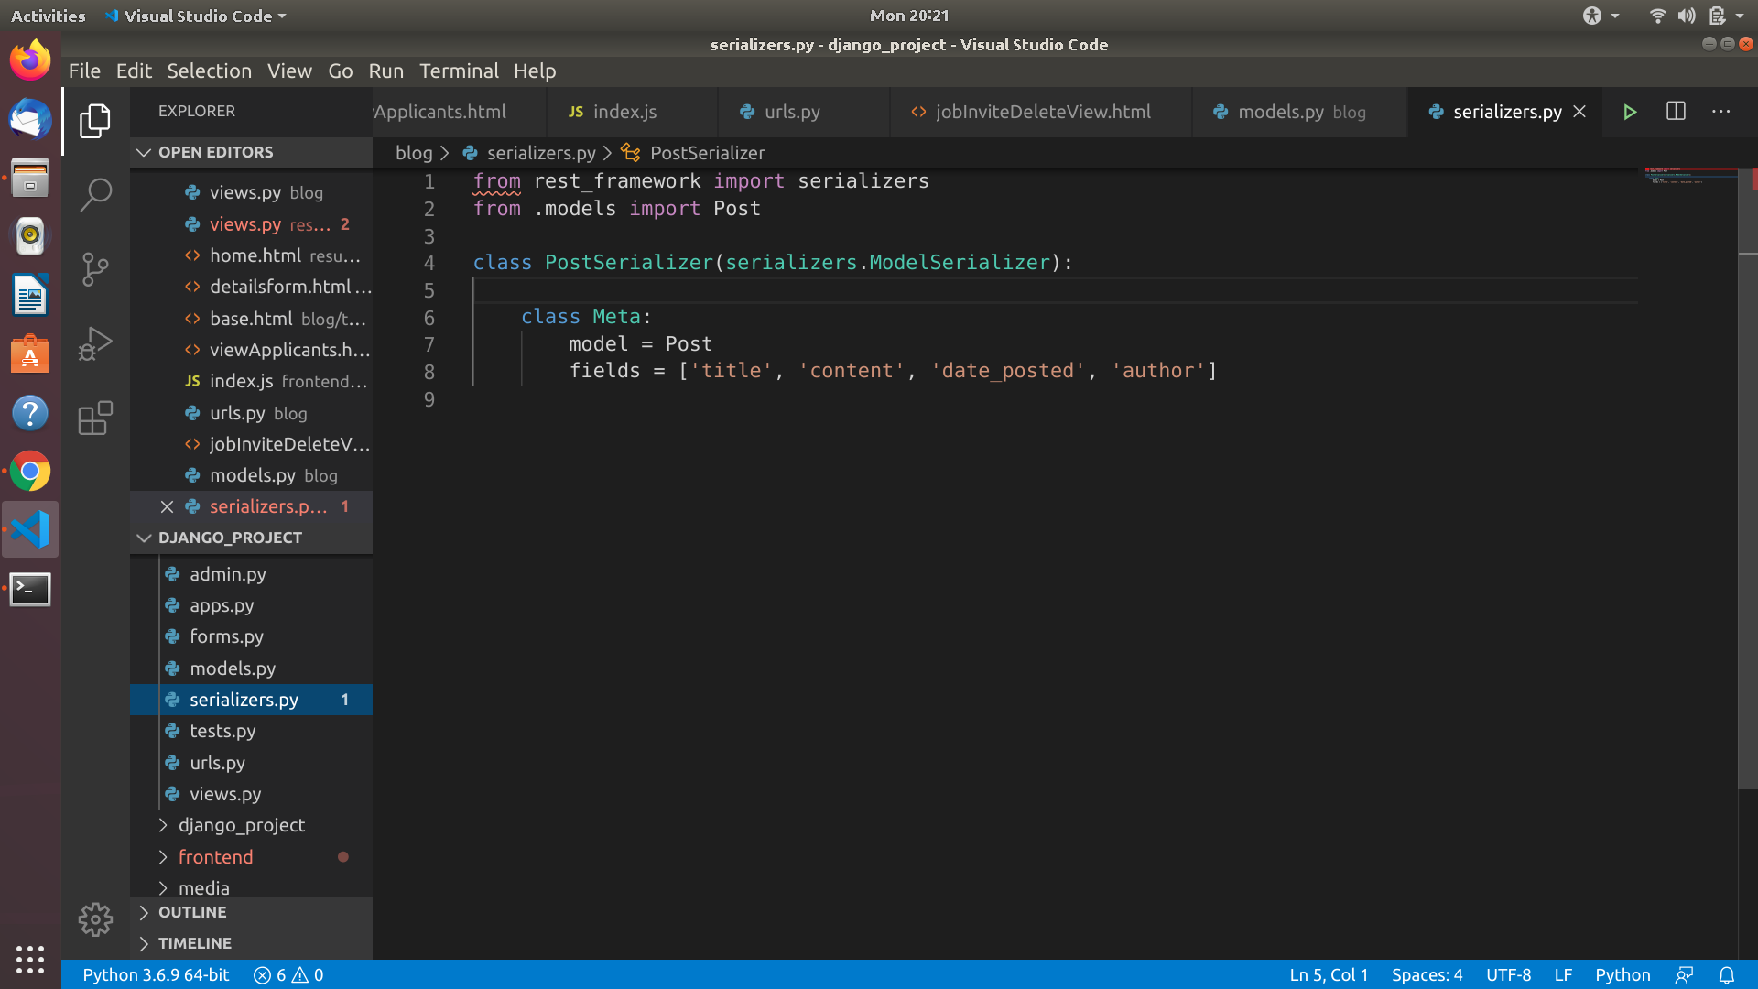

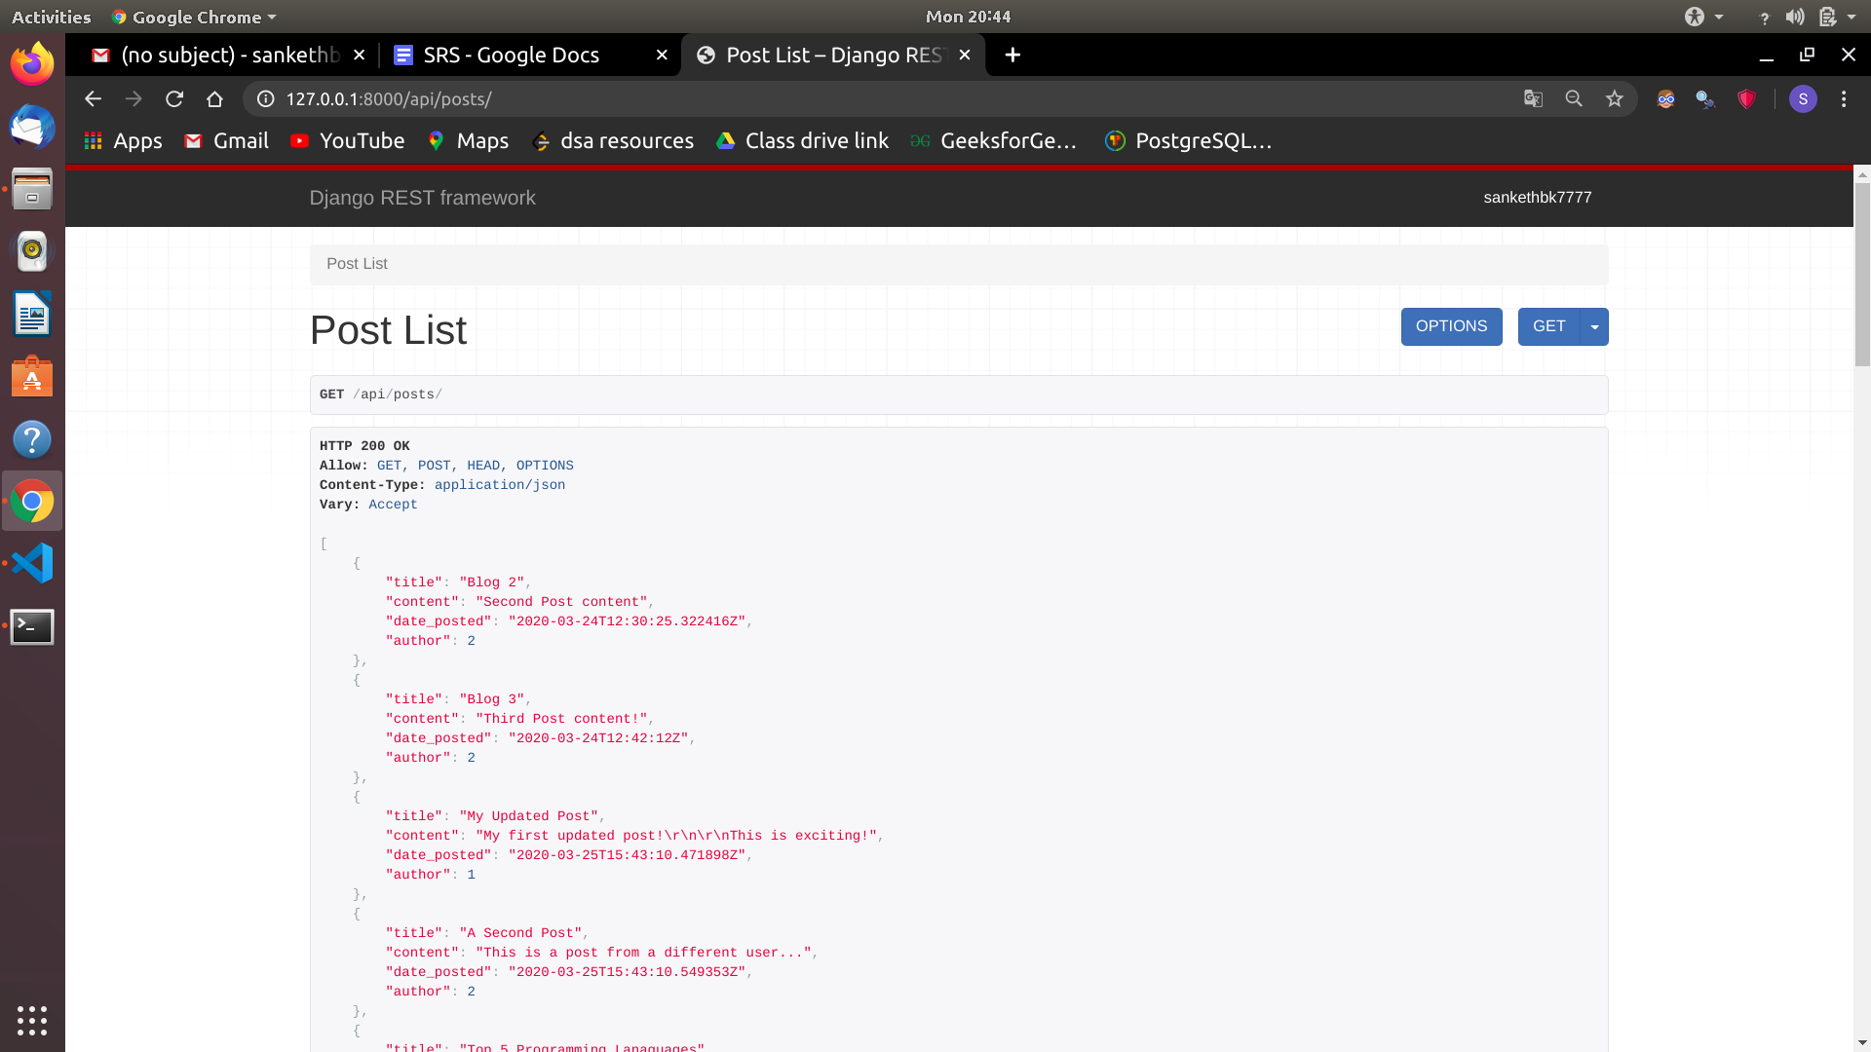

**CONCLUSION AND FUTURE SCOPE:**

As creation of resume and application for jobs is one of the most important requirement in the modern day's generation, our resume builder will be an evergreen resource.

Further this could be taken to next level by integrating a video conference application so that a short interview with the skillful applicants could be held by the manager here itself thus increasing its usability.

Our resume builder could also be made to allow the display of some of the best projects from the applicants, so that the manager could get a good estimate about the applicant.

# **10. Appendices**

**10.1 Definitions, Acronyms, Abbreviation**

Definitions:

**Resume**: Job-seekers create their resume of their chosen styles so that companies can select and give them an invitation.

**Personal details**: Details of customers such as username, company, phone number, address, website, e-mail address etc.

**Contact details:** Details of contact persons associated with the company (customer).

**HTML:** Hypertext Markup Language is a markup language used to design static web page

# **12. References**

1.Django 2 by examples.

2.Official Django documentation.

3.Official React documentation.

4.Building foundation in React.